AETMAAD : FRIENDLY HEALTHBOT

Submitted to

**University of Mumbai**

Submitted in partial fulfillment of the requirements of the degree

#### B.E.

**Computer Science & Engineering (AIML)**

By

**MULLA UMAR BAKHTIYAR 23AI44**

**SHAIKH JAHIR ATIK 23AI51**

**SURVE ARHAAN HALIM 23AI60**

**SAYED NAISH NASIR 23AI48**

Supervisor

**(Prof.Abdul Majeed)**

#### Department of Computer Science & Engineering

##### Anjuman-I-Islam’s Kalsekar Technical Campus School of Engineering and Technology

Plot No. 2 & 3, Sector-16, Near Thana Naka, Khanda Gaon, New Panvel, Navi Mumbai. 410206

**October 2024**



#### Anjuman-I-Islam’s Kalsekar Technical Campus

##### School of Engineering and Technology

Plot No. 2 & 3, Sector-16, Near Thana Naka, Khanda Gaon, New Panvel, Navi Mumbai. 410206

# Certificate

This is to certify that, the Mini Project – 1A entitled

**“Title”**

is a bonafide work done by

**MULLA UMAR BAKHTIYAR 23AI44**

**SHAIKH JAHIR ATIK 23AI51**

**SURVE ARHAAN HALIM 23AI60**

**SAYED NAISH NASIR 23AI48**

and is submitted in the partial fulfillment of the requirement for the degree

**Bachelor of Engineering in Computer Science & Engineering (AIML)**

Submitted to

##### University of Mumbai



Supervisor

**(Prof. Abdul Majeed)**

Project Coordinator

###### (Dr. Tabassum A. Maktum)

Head of DepartmentDean (SoET)

**(Prof.Tabrez Khan)** **(Dr.Rajendra Magar)**

# Mini Project – 1A Approval

This Mini Project – 1A entitled **“AETMAAD : FRIENDLY HEALTHBOT”** by **Name of student 1** MULLA UMAR BAKHTIYAR **Roll No.** 23AI44 **, Name of student 2** SHAIKH JAHIR ATIK **Roll No.** 23AI51**, Name of student 3** SURVE ARHAAN HALIM **Roll No.** 23AI60**, Name of student 4** SAYED NAISH NASIR **Roll No.** 23AI48 is approved in the partial fulfillment of the requirement for the degree of **B. E. in Computer Science & Engineering (AIML).**

Examiners

**1………………………………………. (Internal Examiner Name & Sign)**

2………………………………………. (External Examiner Name & Sign)

**Date:**

**Place:**

**Abstract**

The Aetmaad Health Chatbot is designed to provide personalized healthcare recommendations by interacting with users and suggesting relevant medicinal products from Aetmaad’s offerings. The primary objective is to create a digital healthcare assistant capable of understanding user-reported symptoms, lifestyle factors, allergies, and ongoing medication usage, and then recommending suitable remedies available on Aetmaad’s platform.

The chatbot achieves this objective through a two-step methodology. First, users fill out a form with essential personal and health-related details such as name, age, weight, and address. After submission, they interact with the chatbot, which further asks targeted questions about symptoms (e.g., fever, cough), lifestyle choices (like junk food consumption), allergies, and current medications.

Based on these inputs, the chatbot identifies relevant ailments and suggests appropriate products exclusively from Aetmaad's catalog. Each recommendation includes the product name, price, usage guidance, and a purchase link. The entire conversation is logged in an SQLite database for future reference, ensuring data consistency and smooth follow-up interactions.

Technologies like Python (Flask) for backend processing and HTML, CSS, and JavaScript for frontend design ensure a seamless user experience. The project’s objective of delivering targeted healthcare advice has been met effectively by aligning product recommendations with available Aetmaad products, enhancing accessibility and personalization in health management.

This chatbot not only automates symptom diagnosis and product suggestions but also emphasizes preventive care through lifestyle guidance, thus achieving its goal of offering a well-rounded healthcare solution

## Contents

**Abstract i**

List of Figures iii

List of Tables iv

1. Introduction
   1. Overview **1**
   2. Motivation **1**
   3. Objectives **1**
   4. Organization of Report **1**
2. Literature Survey
   1. Survey of Existing System **2**
   2. Limitations of Existing System **2**
3. Proposed System
   1. Problem Statement **3**
   2. Proposed Methodology **3**
   3. System Design **3**
   4. Details of Hardware and Software Requirements **3**
4. Results and Discussion
   1. Implementation Details **4**
   2. Results **4**
5. Conclusion and Future Work 5

References 6



## List of Figures

* 1. Form Submission Page
  2. Healthbot interface
  3. Product recommendation screen
  4. Healthbot history logging



###### CHAPTER 1

###### INTRODUCTION

###### Overview

In the modern world, people often face difficulties in accessing timely healthcare solutions, especially when it comes to choosing the right medication based on their symptoms. Many individuals rely on self-diagnosis or over-the-counter drugs without proper guidance, leading to ineffective treatment or worsening conditions. This project aims to bridge that gap by creating a chatbot that offers personalized health recommendations based on user symptoms, lifestyle habits, and allergies, ensuring accessible and relevant healthcare support.

###### Motivation

The need for this solution arose from the growing trend of self-medication and the challenges people face in finding reliable product recommendations. Observations revealed that users often struggle with choosing appropriate remedies and lack access to personalized advice that suits their specific symptoms. Additionally, the availability of online health products provides an opportunity to automate recommendations, reducing dependency on guesswork and improving treatment outcomes.

###### Objectives

This project aims to solve the following issues:

* Provide personalized medication recommendations based on symptoms and lifestyle inputs.
* Make healthcare more accessible by suggesting only relevant products available on Aetmaad’s platform.
* Improve decision-making by offering detailed product information, including usage instructions and pricing.
* Automate conversations to reduce the need for in-person consultations for minor health issues.

###### Organization of Report

The report is organized as follows:

* **Chapter 2**: Literature Review – Examines previous work and technologies in healthcare chatbots and symptom-based recommendations.

1

* **Chapter 3**: System Definition – Explains the issue being addressed, including problem categorization, proposed technologies, system architecture, and hardware/software requirements.
* **Chapter 4**: Implementation – Details the system’s design, including code, database structure, and interaction flow.
* **Chapter 5**: Conclusion and Future Work – Summarizes project outcomes and discusses potential improvements for future versions of the system.

2

**Chapter 2: Literature Survey**

This chapter reviews existing healthcare solutions and their limitations, helping us identify gaps and shape the Aetmaad Health Chatbot.

###### Survey of Existing System

* + - **WebMD**: Offers symptom analysis but no product recommendations.
    - **Ada Health**: Provides diagnoses but lacks purchase links for solutions.
    - **Practo**: Requires appointments, causing delays in quick healthcare decisions.
    - **Pharmacy Bots**: List medicines but don’t consider user lifestyle or ongoing medication use.

**Survey Insights**: Users prefer personalized recommendations, direct purchase links, simple interaction, and preventive guidance, which are missing in current systems.

###### Limitations of Existing System

* + - **No Product Integration**: No direct link between symptoms and relevant products.
    - **Limited Personalization**: Lack of tailored advice based on lifestyle and allergies.
    - **Delayed Solutions**: Consultations slow down immediate healthcare.
    - **Preventive Care Missing**: Few bots offer lifestyle guidance.
    - **Lack of Localized Options**: Many bots don’t focus on regionally available products.

3

### Chapter 3: Proposed System

###### Problem Statement

The Aetmaad Health Chatbot addresses gaps in current healthcare solutions by providing **personalized symptom analysis, lifestyle tracking, and tailored product recommendations**. Unlike traditional systems that only diagnose symptoms or recommend general treatments, this chatbot links users to **relevant products available on the Aetmaad platform**, ensuring both convenience and quick access to remedies. It also considers **ongoing medication, allergies, and lifestyle factors** to offer preventive care suggestions.

###### Proposed Methodology

The Aetmaad Health Chatbot utilizes **Flask, Python, SQLite, HTML/CSS, and JavaScript** for smooth operation and interaction. The chatbot follows this methodology:

* + 1. Symptom Detection:
       - Recognizes user symptoms using **predefined keywords** linked to specific health issues.
       - Utilizes a question-based interaction model to gather user details, such as allergies, ongoing medications, and lifestyle habits.
    2. Product Recommendation Logic:
       - Maps symptoms to **curated health products** on the Aetmaad platform (e.g., fever → Tulsi Honey).
       - Generates **purchase links** and displays product prices for easy access.
    3. Database Management:
       - **SQLite** is used to log user interactions, helping improve future recommendations.
       - Conversations are stored for **tracking user history** and providing personalized advice.
    4. User Interaction Flow:
       - The system asks structured questions in stages, offering **dynamic responses**

based on user input.

* + - * Handles greetings and polite closures to ensure an engaging user experience.

4

###### System Design

**Architecture Overview**

The Aetmaad Health Chatbot consists of **modular components** working together:

* **User Interface (UI)**: Developed using HTML/CSS for the form and chatbot screens.
* **Backend**: Python-based Flask app handles logic, routing, and responses.
* **Database Layer**: SQLite stores user conversations and form data.

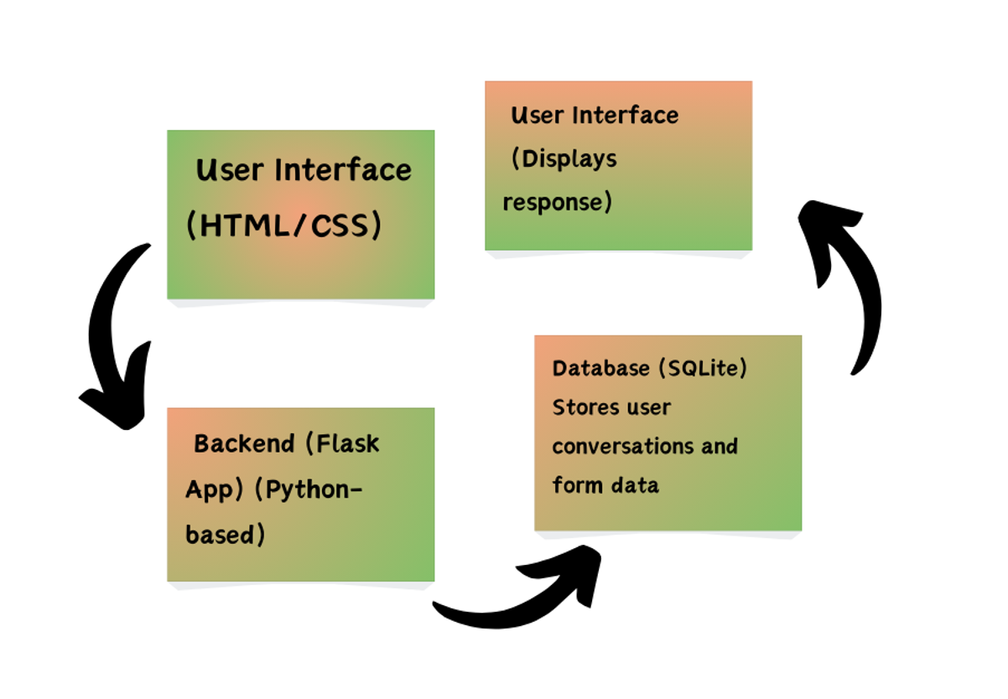

 5

* **API Endpoints**: /chatbot handles user interactions, /submit_form processes personal information.

Data Flow:

* + 1. User fills the form (Name, Age, Symptoms, etc.).
    2. Data is passed to the Flask backend.
    3. Backend identifies symptoms and maps them to products.
    4. Recommended product links are sent back to the user via chatbot.
    5. Interactions are logged in the database for future reference.

###### Details of Hardware and Software Requirements

**Hardware Requirements**

* **Processor**: Intel Core i3 or higher
* **RAM**: 4 GB or more
* **Storage**: 500 MB free space for the database and logs
* **Device**: Desktop or Laptop (for development)

**Software Requirements**

* **Operating System**: Windows 10 or Linux
* **Programming Languages**: Python (Flask framework)
* **Database**: SQLite
* **Frontend**: HTML5, CSS3, JavaScript
* **IDE**: Visual Studio Code or PyCharm
* **Browser**: Chrome/Firefox (for testing)

6

## Chapter 4

**Results and Discussion**

This chapter presents the results obtained from the Aetmaad Health Chatbot, highlighting its effectiveness compared to existing healthcare solutions discussed earlier. The discussion focuses on the system's functionality, user experience, and how the chatbot addresses gaps in existing solutions.

* 1. Implementation Details

The Aetmaad Health Chatbot was implemented using the following technologies:

* + - Backend: Python with Flask to handle chatbot interactions and product recommendations.
    - Database: SQLite for storing user conversations and form submissions.
    - Frontend: HTML, CSS, and JavaScript for designing the chatbot and form interface.
    - API Integration: The system links user-reported symptoms to products available on Aetmaad's e-commerce site.

Process Overview:

1. User Form Submission: The user provides personal details like name, age, and symptoms through a form.
2. Chatbot Interaction: Based on the user input, the chatbot engages with follow-up questions about lifestyle, allergies, and medications.
3. Product Recommendations: The system matches symptoms to curated Aetmaad products and provides purchase links with prices.
4. Logging: Conversations are stored in SQLite for future analysis and improved recommendations.

7

* 1. Results

The Aetmaad Health Chatbot successfully offers personalized healthcare recommendations while maintaining an engaging conversation with users. Below are some key outcomes:

Comparison with Existing Solutions

* + - Symptom Analysis: Unlike WebMD and Practo, Aetmaad Health Chatbot offers customized product recommendations for user-reported symptoms.

* + - Integrated Product Links: The chatbot provides direct product purchase links, unlike other platforms that only suggest general treatments.
    - Lifestyle and Medication Awareness: It ensures preventive care by collecting user lifestyle and allergy data, which many other solutions lack.

Observed outcomes

* + - User Engagement: The structured flow of questions keeps the conversation easy to follow.
    - Accurate Product Mapping: Recommendations align well with the user's symptoms and needs.
    - Convenience: Users can seamlessly purchase health products without needing external consultations.

Screenshots of Implementation

1. Form Submission Page
   * A simple and intuitive form that captures the user's personal and health-related data.
2. Chatbot Interface
   * A friendly chatbot greeting the user and asking relevant questions about their symptoms.
3. Product Recommendation Screen
   * The chatbot suggests products with prices and direct purchase links.
4. Conversation History Logging
   * SQLite database entries showing saved user messages and bot responses.

8

SCREENSHOTS :

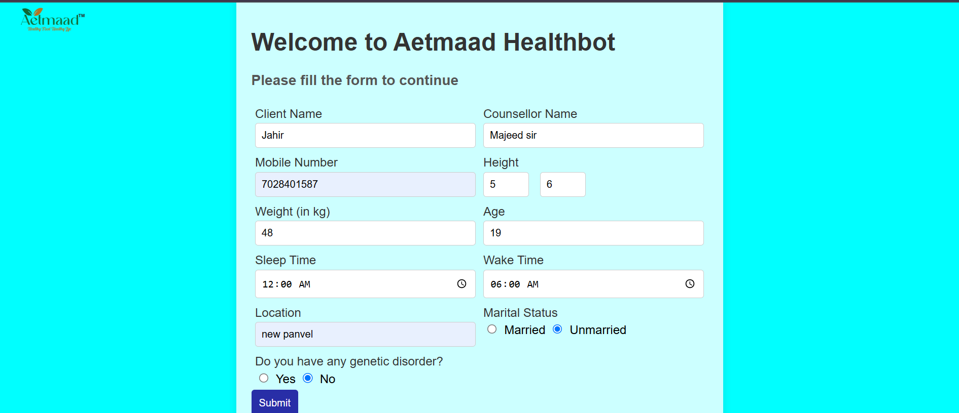



9

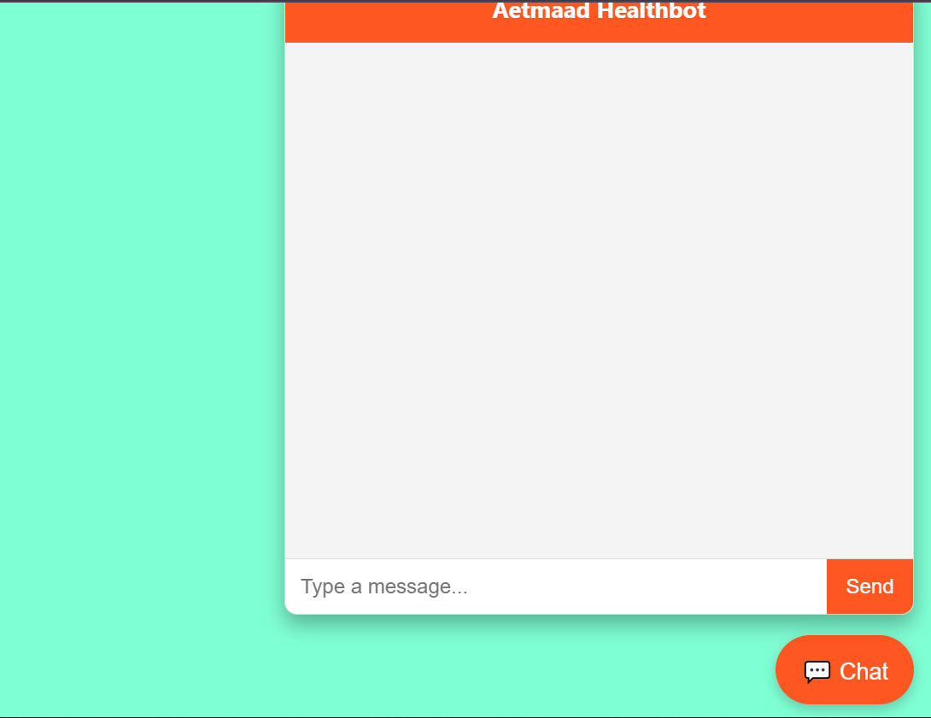

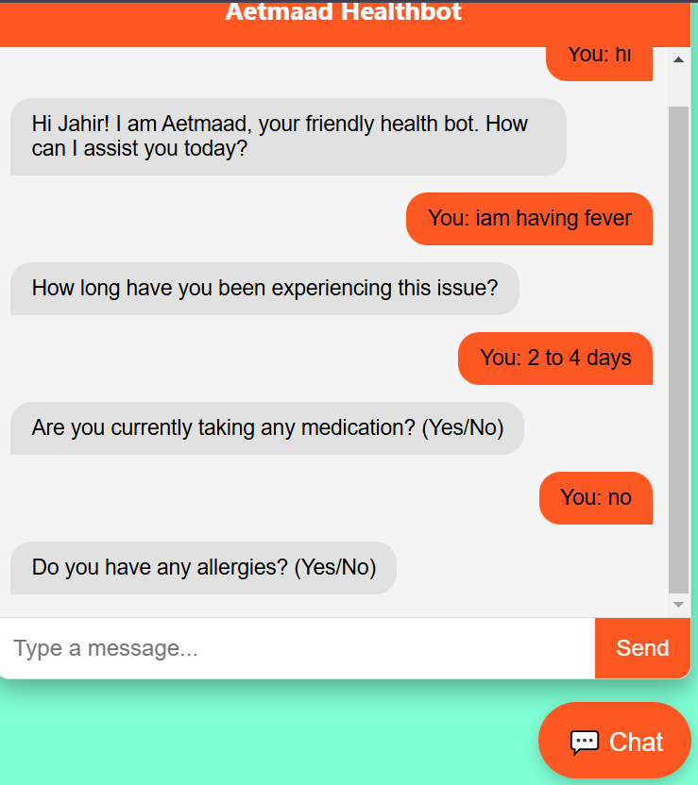

10

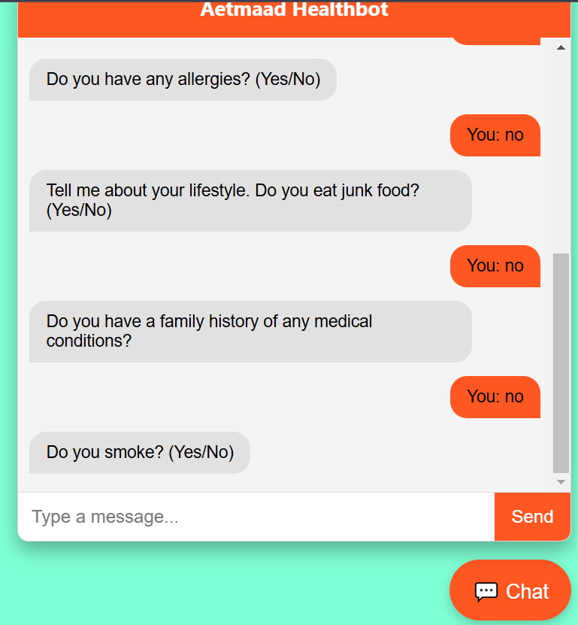

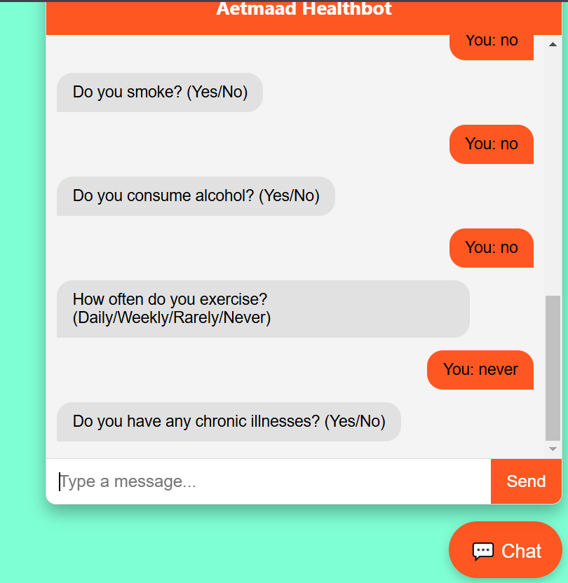

11

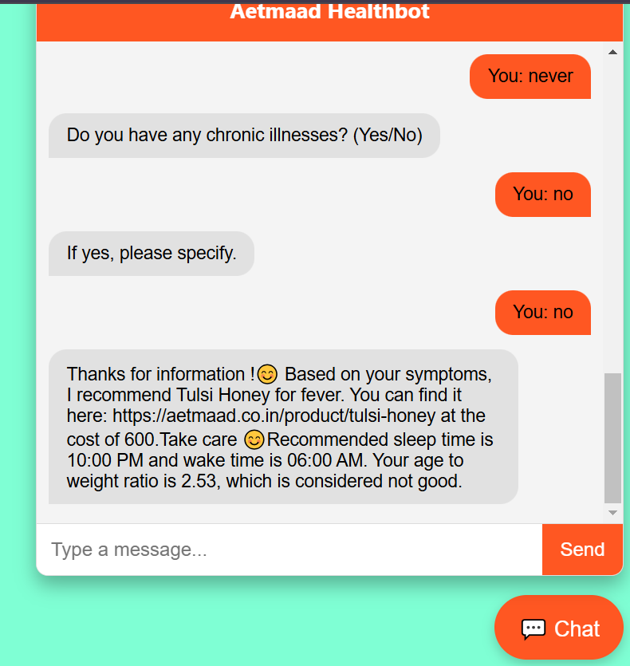

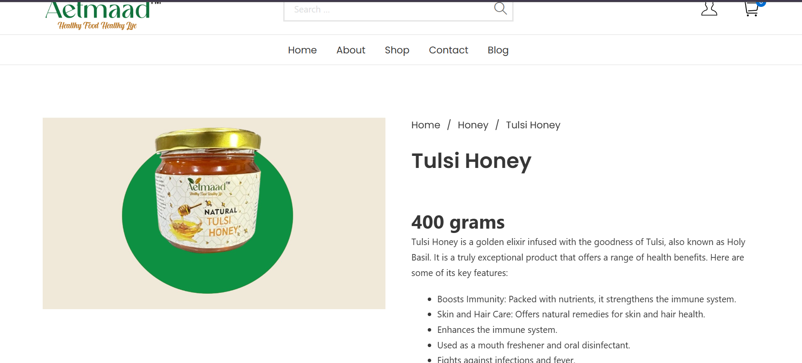

12

Discussion

The results demonstrate that the Aetmaad Health Chatbot offers an innovative approach to bridging healthcare recommendations and product purchases. The chatbot’s success lies in integrating symptom analysis, lifestyle awareness, and preventive care with product accessibility. The stored conversation data helps improve recommendations, making the system more reliable over time.

Compared to existing solutions, our chatbot stands out due to its seamless user experience, instant product availability, and focus on preventive health advice. The approach is scalable, as it can easily integrate new symptoms and products into the system.

13

## Chapter 5

**Conclusion and Future Work**

The **Aetmaad Health Chatbot** was developed to offer **personalized healthcare recommendations** by analyzing user symptoms, lifestyle factors, and allergies. It bridges the gap between **symptom diagnosis and product availability** by suggesting relevant medicinal products from the Aetmaad e-commerce platform. The primary objective was to provide users with **quick, actionable health solutions** while ensuring **ease of purchase**—a goal we successfully achieved.

Some key achievements include:

* + - **Efficient Symptom-Product Mapping**: Users received accurate product recommendations for various health issues.
    - **Engaging User Experience**: The chatbot provided a friendly, interactive interface, making it easy for users to communicate their health concerns.
    - **Real-Time Data Logging**: Storing conversations in a database enables continuous learning and system improvement.
    - **Preventive Care Focus**: By asking about lifestyle habits and allergies, the system encourages users to adopt healthier choices.

The project has been an enriching learning experience, providing insights into **natural language processing, database management**, and **user-friendly design principles**. It also highlighted the importance of **personalization in healthcare**.

14

###### Future Scope

While the Aetmaad Health Chatbot has been successful, there are several areas for further enhancement:

1. Integration with Machine Learning Models:
   * Future versions can utilize **NLP models** to improve symptom interpretation and recommendation accuracy.
   * **User feedback loops** could refine product suggestions based on real-world outcomes.
2. Multi-Language Support:
   * Adding support for **regional languages** would make the chatbot accessible to a broader audience.
3. Expanded Health Data Analysis:
   * Integrating wearable device data (like heart rate, sleep tracking) could offer more

personalized health advice.

1. **Voice-Activated Chatbot**:
   * Future iterations could support **voice-based interactions** to enhance usability, especially for elderly users.
2. Broader Product Database:
   * Expanding the product catalog and including **partner pharmacies** would increase product variety and availability.
3. Integration with Healthcare Providers:
   * The system could eventually **connect users with doctors or counselors** for complex cases requiring professional consultation.

15

## References

Since the primary source of data used in the project was the Aetmaad website for product and symptom-related information, we acknowledge it as the key reference. No additional books or research papers were consulted.

[1] Aetmaad, **Medicinal Products and Health Solutions**, [https://aetmaad.co.in](https://aetmaad.co.in/)

This project relied exclusively on this source for product details, pricing, and relevant health recommendations.

16